LAB3_4

setwd(".")  
library(knitr)  
library(ggplot2)  
library(sqldf)

## Loading required package: gsubfn

## Loading required package: proto

## Loading required package: RSQLite

library(DMwR2)

## Registered S3 method overwritten by 'xts':  
## method from  
## as.zoo.xts zoo

## Registered S3 method overwritten by 'quantmod':  
## method from  
## as.zoo.data.frame zoo

#APARTADO A

#Calcular la probabilidad de que sea mayor o igual a 5.5  
lambda<-3  
p55<-ppois(5.5,lambda)  
mu<-lambda  
sigma<-sqrt(lambda)

#APARTADO B

px1y6_con1<-ppois(6,lambda)-ppois(0,lambda)  
px1y6_sin1<-ppois(6,lambda)-ppois(1,lambda)

#APARTADO C

#Calcular el 5% de los valores mas bajos.  
per75<-qpois(0.75,lambda)

#APARTADO D

#Calcular el 5% de los valores mas bajos.  
per5<-qpois(0.05,lambda)

#APARTADO E

set.seed(35200)  
sample<-rpois(500,3)  
media_sample<-mean(sample)  
sd_sample<-sd(sample)  
hist(sample, breaks=seq(-0.5,max(sample+0.5)), col="lightblue", freq=F, add=F)

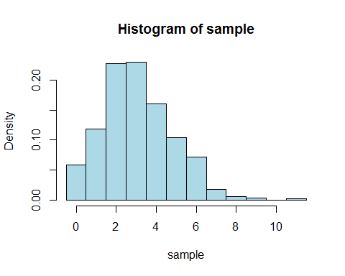 #APARTADO F

#Pillamos lambda por defect (3).  
x<-seq(0,max(sample)+1)  
  
x2<-seq(0,30)  
fx<-dpois(x2,lambda)  
fx2<-dpois(x2,2*lambda)  
fx3<-dpois(x2,4*lambda)  
plot(x2,fx3, col="red",type="b", lwd=2, pch=19)  
points(x2,fx2, type="b", col="darkgreen", lwd=2, pch=19)  
points(x2,fx, type="b", col="blue", lwd=2, pch=19)

